2015 Summer Reading Assignment for Juniors Entering English 11

Prior to returning to school in the fall, read Lord of the Flies by William Golding. You may buy the book, borrow it from a friend, or check it out of the library. Barnes and Noble in Pickerington will have copies, or it can be purchased very cheaply online. As you read the novel, complete BOTH of the assignments explained below, on paper or electronically. Please read the directions carefully to ensure you meet expectations. There will be an assessment in the second week of school over this novel and class discussions.

DUE DATE: Friday, August 21
LATE WORK ACCEPTED UNTIL: Friday, August 28 at 2:00; no work accepted after this time.
GRADING: 50 points total (30 journal + 20 collage); late work subject to 50% penalty

Assignment #1: Diary/Journal Entries
Choose a character and create 10 diary or journal entries (around 150 words each, which is the length of this paragraph) from that character’s perspective. Take on the persona of your chosen character and discuss his reactions to at least 10 different scenes or situations that take place in the book. In your entries, consider what your character may have been thinking during certain scenes or why he may have acted the way he did; DO NOT merely summarize the plot! Be sure to refer to specific character names, events, and situations as you write; your goal is to make it clear that you have read the entire novel and have a solid understanding of its storyline and characters. The entries should be written in 1st person narration and should cover events in the beginning, middle, and end of the story. This journal should be your own creation. Using other people’s words or thoughts as your own is plagiarism. Anyone found plagiarizing, cheating, copying, or misrepresenting their work in any way will receive a ZERO.

Assignment #2: Collage
Based on the novel, create a COLORFUL collage consisting of the following elements of the novel: author, title, setting, important plot points, significant images, symbols, and meaningful quotations. Be creative as you work towards building a visually appealing representation of the book you have read. These collages can be in the form of a hard copy (poster board) or a digital copy (stored on a flash drive or sent through email). Do NOT use pictures of the cover of the novel or stills from the movie for this collage; that’s not creative! This collage should be your own creation. Using other people’s words, thoughts, or artwork as your own is plagiarism. Anyone found plagiarizing, cheating, copying, or misrepresenting their work in any way will receive a ZERO.

Here is an example using the novel The Poisonwood Bible by Barbara Kingsolver:
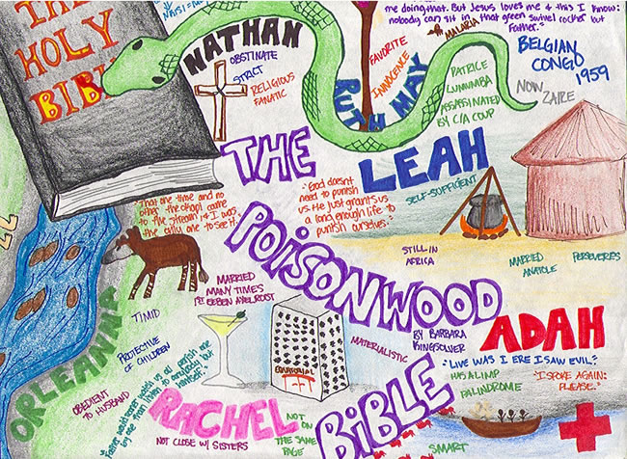

**If you have any questions over the summer, please contact Mrs. Brooks at jbrooks@reyn.org. Please allow 2-3 days for a response.

