RHS Encore Academy
Summer Reading 2014
English 9
Prior to returning to school in the fall, read ONE of the following two novels:
13 Reasons Why by Jay Asher
the curious incident of the dog in the night-time by Mark Haddon
Unwind by Neal Shusterman

As you read the novel you have chosen, complete BOTH of the accompanying assignments explained below. These assignments will be presented to the class during the second week of classes, August 18-22, 2014.
Assignment #1: Diary or Journal Entries
Directions: Choose a character and create 10 diary or journal entries (minimum 75 words in length each) from that character’s perspective. Take on the persona of your chosen character and discuss his/her reactions to at least 10 different scenes or situations that have taken place in the book. In your entries, be sure to provide names, character traits, and relevant background information of other characters in the novel as well. The entries should be written in 1st person narration and should cover the entirety of the novel. (For example, if your book has 200 pages, you might decide to stop reading and complete a journal entry about every 20 pages.) In other words, the scenes, situations, and characters you discuss should not all come from the one part of the book. Through your entries, make it clear that you have read the entire novel and have a solid understanding of its storyline and important literary elements.
- This journal should be your own creation; please do not copy other people’s words or thoughts; that is plagiarism and will result in a ZERO.
- Do NOT use sparknotes or bookrags or any other web source. Copying from these websites is plagiarism and will result in a ZERO.
Assignment #2: Collage
Directions: Be creative! Design a visually appealing representation of the book you have read. Based on your novel, create a poster about your novel: who are the main characters ? what is most interesting to you about them and their stories? what message (or two!) does the story convey to you? Be sure to include the author and title! Show important elements of the setting and plot. Consider including significant images, symbols, or meaningful lines from the story. These collages can be in the form of a hard copy (poster board, scrap book page, canvas) or a digital copy (stored on a flash drive or sent through email). This collage should be your own creation; please do not copy other people’s pictures, words, etc.; that is plagiarism. Here is an example:
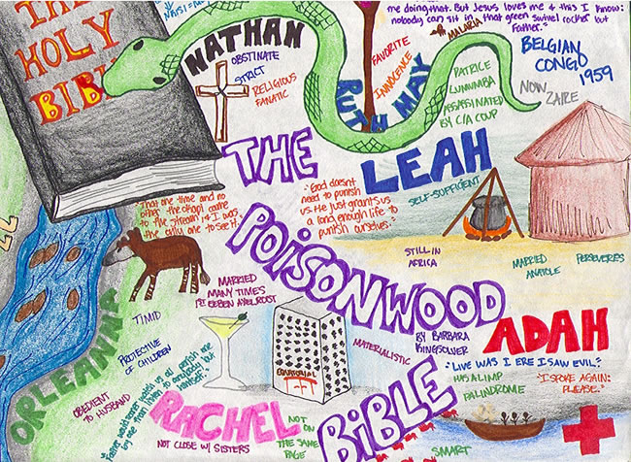
**If you have any questions, Encore English teachers can be contacted through email at the following addresses:
Seniors: Mr. Alexander talexander@reyn.org Sophomores: Mr. Tartt startt@reyn.org
Juniors: Mrs. Brooks jbrooks@reyn.org Freshmen: Mrs. Hoover khoover@reyn.org

