RHS Encore Academy
Summer Reading 2015
English 9—Miss Guitner
Prior to returning to school in the fall, read the following novel:
Keesha’s House by Helen Frost

As you read the novel, complete BOTH of the accompanying assignments explained below. These assignments will be discussed and presented in class during the first two weeks of classes, August 17-28, 2014. We will also be completing in-class assignments and will take a final assessment over this book so it is important that you read it carefully.
Assignment #1: Reflection Poems
Directions: This assignment may be completed in two ways.
- Choose a character and create 4 additional poems from that character’s perspective. Your poems should be modeled after two or more poetry forms as explained in the back of the book. If you chose this route, you must decide where these poems will fit into the story line. Do they happen before the story begins, after the story ends, or somewhere in the middle? Try to stay true to the character you choose by taking on his or her persona. Be sure to provide the name of the character at the top of the page.
- Write from your perspective and create 4 additional poems from your own perspective as if you were a part of this story. Your poems should be modeled after two or more poetry forms as explained in the back of the book. If you chose this route, you must decide where these poems will fit into the story line. Do they happen before the story begins, after the story ends, or somewhere in the middle? Try to stay true to the story by pretending as if you fit into the plot line.
- These poems should be your own creation; please do not copy other people’s words or thoughts; that is plagiarism and will result in a ZERO. Also, copying from these websites is plagiarism and will result in a ZERO.
Assignment #2: Collage
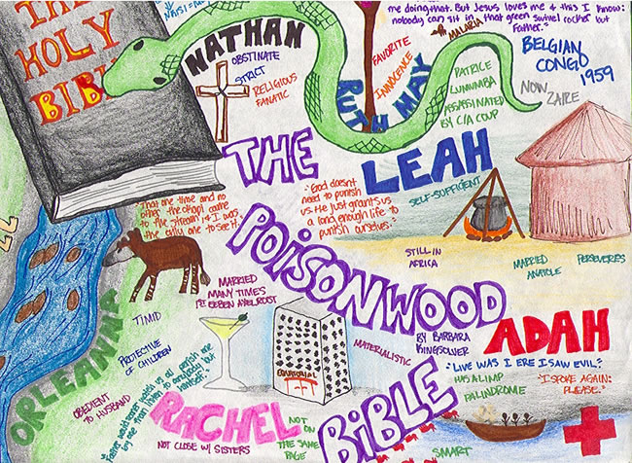
Directions: Be creative! Design a visually appealing representation of Keesha’s House. Based on your novel, create a poster about your novel: Who are the main characters? What is most interesting to you about them and their stories? What message (or messages) does the story convey to you? Be sure to include the author and title. Show important elements of the setting and plot. Consider including significant images, symbols, or meaningful lines from the story. These collages can be in the form of a hard copy (poster board, scrap book page, canvas) or a digital copy (stored on a flash drive or sent through email). This collage should be your own creation; please do not copy other people’s pictures, words, etc.; that is plagiarism. Here is an example:

**If you have any questions, I (Miss Guitner) can be contacted through email at: alissa.guitner@reyn.org. I look forward to meeting you soon!**

