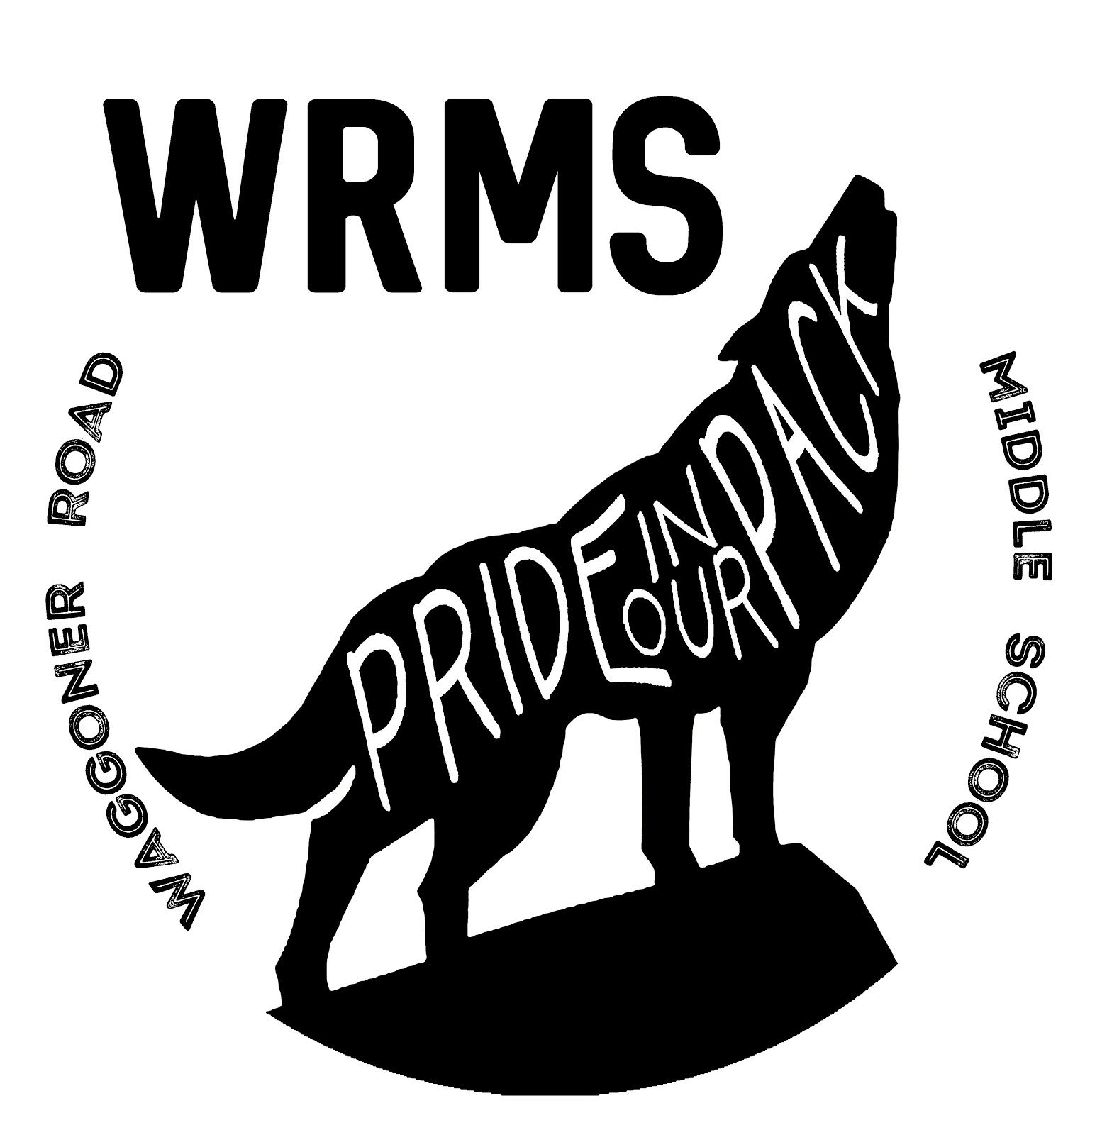
2020-2021 Supply List for 5th and 6th Grade Waggoner Road Middle School

Each student must have a 2” binder with them each day. Tabs will be used to organize their notes, work, etc. by class in this binder. Students will also need a pencil pouch or school box to hold earbuds and their other belongings as they will need to keep their supplies separate from their classmates. Our students will not be physically switching classrooms so their supplies will be stored in their desk during the day and taken home each night.

Students will take their Chromebook home so we suggest a soft sleeve or a backpack meant to hold a laptop to hold the Chromebook (11.6”) but it is not required. We highly recommend purchasing a plastic backpack as it is easier to sanitize. Students may not leave any items at school so please be sure to find a backpack that will comfortably hold a chromebook, their binder, a book, and school box/pencil pouch.

Label ALL ITEMS with your child’s FIRST AND LAST NAMES prior to the first day of school! You do not need to send all items into the building on the first day; keep some of it in a safe place at home so that it can be easily found when their supplies need to be refreshed or replenished.

Since we are starting online, the supplies highlighted in teal below are essential. Once we return to school, students will then need the unhighlighted supplies. We recommend being prepared to create a workspace at home for any remote learning days. This workspace should have easy access to their school supplies and an outlet for Chromebook charging.

Item | Quantity/Package Size
Expo Dry Erase Markers (black) | 4 markers
Earbuds or Headphones | 1 but be ready to replenish!
Hand Sanitizer* | 3-8 oz. bottles...be prepared to replenish throughout the year!  Students may also want to have their own at their desk.
Tissues* | 2 standard size boxes  Students may also want to have individual packs or bags of tissues of their own at their desk.
Clorox/Lysol Wipes* | 3-75 ct. packages...be prepared to replenish throughout the year!
Pencils | At least 48...be prepared to replenish throughout the year!
Crayons | Box of 24
Colored Pencils | Box of 12

 | Highlighters | 1 package of 4 different colors
 | Pens | 1 black  1 red or green 1 blue
 | Lined Index Cards | 2 packs of 100
 | Scissors | 1 pair (select a size that appropriately fits your child’s hand)
 | Glue Sticks | At least 2 gluesticks
 | Loose Leaf Wide Ruled Notebook Paper | 2 packs of 100
 | Loose Leaf Graph Paper | 1 pack of 100
 | PLASTIC Folder with 2 pockets AND prongs | 1-color or design of choice
 | Pencil Pouch or School Box | 1-color or design of choice...make sure it has a zipper or snaps to close and is labeled with your first and last name!
 | 2” Binder with “D” or “slant” rings | 1-color or design of choice
 | Composition Book | 2-color or design of choice
 | 5 Tabbed Dividers with Reinforced Holes | 1 set of 5
 | Pencil Sharpener | 1 personal/small pencil sharpener
 | Backpack | 1 (plastic highly recommended as it is easier to sanitize)
 | Chromebook Sleeve (optional) | Our Chromebooks are 11.6”; they will be taken home nightly so we highly recommend either a sleeve or a backpack meant for laptops.
 | Masks | At least 2 but more are suggested so that they can be washed after each day  Per the Reynoldsburg Responsible Restart Plan, all students are required to wear masks at the bus stop, on the bus, and in the building. These masks must cover the mouth and nose.
*No supplies will be collected by teachers other than hand sanitizer, tissues, and Clorox Wipes. We understand that these items may be hard to come by. If you’re not able to obtain right away but can send in donations of these items at a later date, we would greatly appreciate it!

