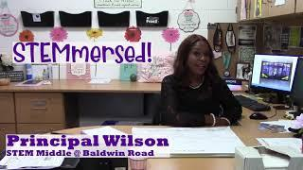
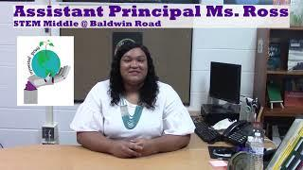
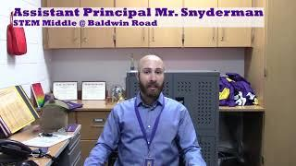
Welcome Back! ~ with Principal Mrs. India Wilson!
Welcome Video

Daily Learning Expectations & Scheduling with Assistant Principal Mrs. Schyvonne Ross

Expectations Video
Grading Policies & Schedule Fixes with Assistant Principal Mr. Maxwell Snyderman

Grading Video

Please take a few moments to complete the following google form to provide a digital copy of your contact information. This information is essential for our staff members to support you and your student this school year. STEM Middle is dedicated to supporting our students and keeping open lines of communication!

Family Communication Google Form

“Education is the most powerful weapon which you can use to change the world.” ~ Nelson Mandela
Below you will find specific grade level webpages (“landing pages”) with information about the upcoming school year, teacher contact information, and more. Please take some time to investigate your student’s schedule and “meet” your teachers utilizing the links provided.
GRADE
GRADE
GRADE
GRADE

5th 6th 7th
8th

Team Website (Landing Page) Teacher Video ☺

Team Website (Landing Page) Teacher Video ☺

Team Website (Landing Page) Teacher Video ☺

Team Website (Landing Page) Teacher Video ☺
Special thanks to Mrs. Heath for the filming & editing of the fifth-grade team video!

Special thanks to Ms. Rossi for the filming & editing of the sixth-grade team video!

Special thanks to Mrs. Fowler for the filming & editing of the seventh-grade team video!

Special thanks to Mrs. Erre for the filming & editing of the eight-grade team video!

Electives Landing Page
Band Economics We the People

Choir

Chinese

Zoology - Supe Environmental Sustainability Zoology - Teaford

Computer Science Globalization
Multimedia Design
Design Marine Biology Orchestra

Robotics

Physical Education

Spanish

5th Grade Music

Ms. Kinnell, Mrs. Featherstone, & Mrs. Droese

Welcome Back Video

English Language Learners

With Mr. Papas

Mr. Papas’ Landing Page

‘Reading Rockstars & Steigerwald
Learning Centers @ SMBR Landing Page

with Ms. Sandra Kageorge!

Check out the links below with important information from our school nurse!

Letter From Your School Nurse

Reynoldsburg Vaccine Clinic Flyer August 2020

Required Immunization Paperwork – 7th Grade

Prescription Medication Form

Check Out Our Landing Page Here
Covid-19 Symptoms Information
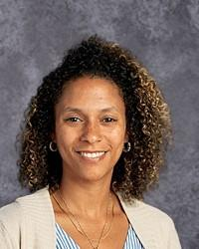
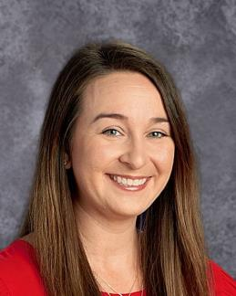
Counselors’ Corner & Scheduling
Mr. Moon
Mr. Lash

With Ms. Ashley Artis
&

With Ms. Angela Rahe

Hi! Meet Ashley Artis, school counselor, and Angela Rahe, school social worker, at STEM Middle at Baldwin Rd. Jr. High. We look forward to assisting students and their families during this unprecedented time. Together, we work to increase social/emotional learning, provide individual and group counseling, provide crisis intervention and conflict resolution, and connect others with school and community
resources. Additionally, Ms. Artis specializes in scheduling, testing, 504
plans, college/career development, and academic support. Ms. Rahe specializes in attendance concerns, clinical mental health counseling (i.e. anxiety, depression, etc.), referrals and linkages with community mental health services, and teaching coping and calming skills. We are excited to start the 2020-2021 school year, and we are so glad you’re here!

Learning Center Paras

Mr. Lash is originally from Huber Heights OH. He attended North Carolina Central University. He is an active member of our athletic department. Mr. Moon loves working with children through their time in education. He also runs a dance studio for Children. Mr. Lash and Mr. Moon are here to support our students at STEM Middle! He cannot wait to welcome you back!

&

This year, SMBR will be on Block schedules. A block schedule allows teachers to spend extended time on core content. Therefore, the class does not meet every day, but instead on A & B days. A Days = Monday/Thursday and B days = Tuesday/Friday. Wednesdays will allow for independent completion of A/B assignments.

A/B Schedule

Counselors’ corner Landing Page

Parent Guide to Learning – District Paperwork

Schedule Correction Form *Please fill out the form above with any correctionsneeded to
your current schedule (i.e. missing classes, duplicate classes, etc.)

