CHANGE OF STUDENT ADDRESS (and/or CUSTODY)
. . . .
of d str
ct
out- - i - Enro ment
res1d1ng i Open ll .
_

Requires TWO valid proof of new address:
1. SIGNED lease (in its entirety), Purchase Agreement or Notarized Friends/Family Affidavit PLUS 2. Utility bill, insurance statement with current address or some sort of official mail
Copies of required documents will be made at the Welcome Center and retained as part of the student's permanent record.

TRANSPORTATION DEPT: Changes will not be updated until proper validation is received by the Welcome Center. Transportation changes may require 2-3 business days waiting period.

Change of Custody: requires proof of court order -judge signed and with seal or agency documentation \

Today's Date: _

Effective Date: -

____________

------------
D residing within RCSD boundaries
□ Applying to remain under District of Residence: ___ _ ____

Student's Name ------------------ Grade --- ID# _______ Gender --- Date of Birth - - - - - School Building: _______ _____ Former Street Address -------------------------------

New Street Address ______________ _ _ ______ Apt./Lot# ___
City/Zip _____________ County: D Franklin D Licking D Fairfield
Does this move require a change in SCHOOL BUILDING? 0 YES □ NO □APPROVED
Intra-district
If YES, From: ________ to __________ (no bus transportation)

How will your student ARRIVE TO school? Bus __ Parent

How will your student LEAVE FROM school? __ Bus __ Parent

___ Daycare

___ Daycare

--Walk / Drive

--Walk / Drive

Has this move resulted from a change in CUSTODY, DIVORCE/SHARED PARENTING? 0 YES □ NO It is required under Ohio Revised code that ALL custody documents be submitted when the event is effective.
(ie. divorce, dissolution, shared parenting, court order)

Residential Parent/Guardian 1 NAME ___ ______________________ Relationship to student: ________ Contact Phone#( __) __________
Residential Parent/Guardian 2 NAME __________________________ Relationship to student: ________ Contact Phone#(__ ) __________

Parent/Guardian Signature: ____ ______________ Date: ________
REYNOLDSBURG CITY SCHOOLS

Welcome Center
1555 Graham Road, Reynoldsburg, Ohio 43068 Phone: 614-501-1033 Fax: 614-501-1049

Residency Verification Release
To be completed by families renting/leasing their home. Form MUST be completed by the leaseholder.

Lease Holder's Name: -----------------------Address: ______________ City/Zip: __________

Primary Phone Number: ______________________ Lease begins (date):____ Lease ends (date): ______ Month-to-month

REQUIRED

Landlord / Rental Agent's Name: ___________________ Phone Number: _________________________ Address: City/Zip: __________

I hereby authorize Reynoldsburg City Schools to contact my Landlord/Rental AgenUProperty Manager in order to verify my residency at the address of record with the District, both at the time of enrollment and/or at any time during my child's enrollment. I understand that lack of proper proof of residency or falsification of information provided will result in my student's withdraw from Reynoldsburg City Schools.

Lease Holder PRINT NAME: ----------- - --

------------------
Lease Holder Signature Date

Student( s ):

(Name) (D.O.B.)

(Name) (D.0.B.)

(Grade)

(Grade)
(Name) (D.0.B.)

(Name) (D.0.B.)
(Grade)

(Grade)

www.reyn.org 7244 E. Main Street, Reynoldsburg, Ohio 43068 (614) 501-1020

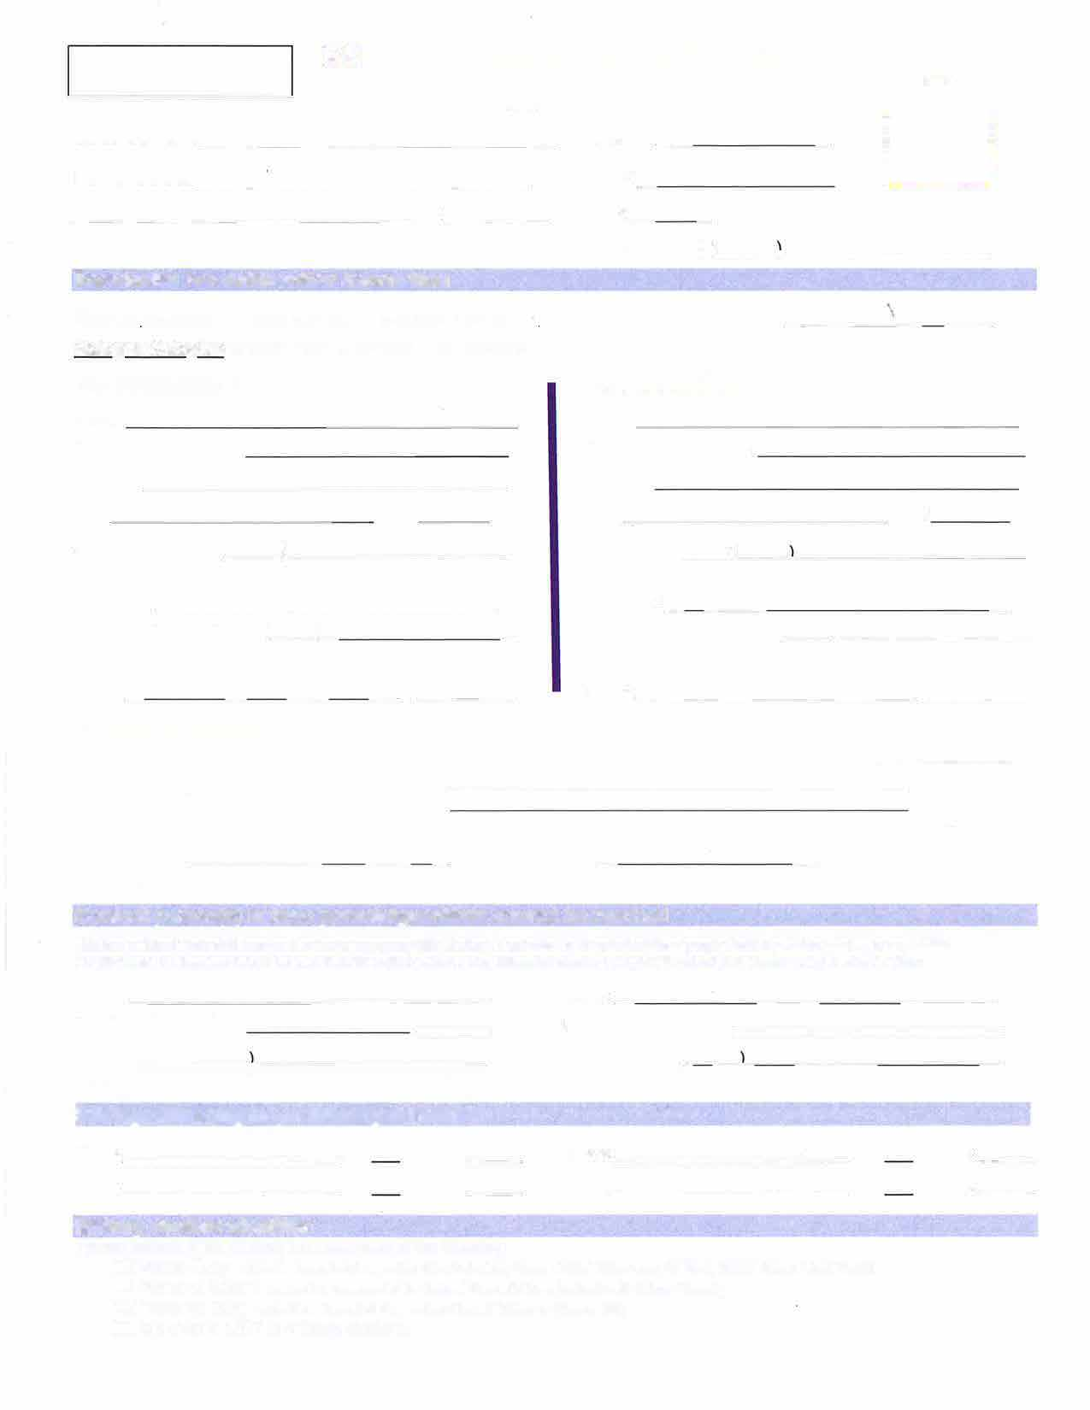
FOR OFFICE USE: SIS#
_
_
_
□
--
Contact Phone:/� �-----------­
-
­
:
D
REYNOLDSBURG CITY SCHOOLS EMERGENCY AUTHORIZATION FORM O.R.C.3313.712

Student's Name------------------Home Address -----------------
_________________ Zip: ____ _
Birthdate: --------

School: - - - - - - - --
Grade: __ _ Gender □ M OF

Student's Cell Phone: (___ _,___________ Residential Parent/Guardian Information
Student lives with: □ both parents □ parenVguardian 1 □ parenVguardian 2 □ other ________ _ Biological/AdoQtive parents are: □ Married □ Divorced □ Single-never married □ Residing together-not married

Parent/Guardian 1

Name:
Relationship to student:

Address:
Parent/Guardian 2

Name:
Relationship to student:

Address:

City: Zip: City: Zip:

Contact Cell Phone:( __ ) __________ Can this number receive text messages? D YES D NO

Contact Cell Phone:(�-�-- - -- - - - -­ Can this number receive text messages? D YES D NO

Employer: _________________ Employer: _ ______________

Additional Contact Phone: L__j_ _ _ _ _ _ _ _ This contact number is: D Work D Home/Land line D Additional Cell Phone
Additional Contact Phone: (__ )__________ This contact number is: D Work D Home/Landline D Additional Cell Phone

Email: _ _ _ __ ___ __@____ _ Email: ______________ @_____

Custody (if applicable):
Is this child subject to any shared parenting agreement

□ custody order □ guardianship □ foster placement □ _______

Name and mailing address of other parent if order mandates: ______________________

Is there a court or police filed document that restricts access to this student by any party (i.e. Protection Order)? □ Yes □ No If YES, whom: _______ ____ Relationship to child: __ _ _ _ _ _ _ _
***This order cannot be executed until the document has been submitted to the Welcome Center which will be forwarded to student's school file. •••

Contact person(s) in case parents/guardians cannot be reached
This form is utilized if your child becomes ill or has an emergency while at school. It authorizes us to contact additional people should a parent or guardian be unavailable.
For this reason, it is important that you list more than one contact number. If your information changes throughout the school year, please be sure to notify the office.
Name: ------------------ Name: _ _ _ _ _ ____ _ _ ____ _ Relationship to student: _ _ _ _ _ _ _ ___ _ Relationship to student: ____________ _

Contact Phone:/ ---This contact number is: D Cell Phone D Home/Land line D Work This contact number is: D Cell Phone
----- - - - -D Home/Land line D Work

Siblings attending Reynoldsburg Schools

Name: ___________ Gr.:

Name: ___________ Gr.:

School: ___

School: ___

Name___________ Gr.:

Name:___________ Gr.:
School: ___

School: ___

Military Student Identifier
Please indicate if this student is a dependent of the following:
Active Duty: student is dependent of a member of the Active Duty Forces (United States Army, Air Force, Marine Corps or Coast Guard}
D National Guard: student is a dependent of the National Guard (US Army National or Air National Guard}. D Reserve Duty: student is a dependent of a member of the US Military on Reserve Duty
D My child is NOT a military student. (Revised 9/23)
Student's Name: _______ _ ___ _ _ _ _ _
\
Name of Medication | Taken for Activity Restrictions
-
_

Med ica.l Alerts

My child has NO medical concerns x__________________ _ parent/guardian signature

Major Medical Concerns (list as follows): ______________________

Routine MEDICATIONS (including those taken at home): D NO Medications

ALLERGIES: 0 NO Allergies
D Food: ------------- D Drug: ____________ _ D Insects: ---------- D Other: _____________ 0 EPI-PEN NEEDED D Seasonal/Environmental: --------

Per our family religious convictions, this student does not consume the following food: ________ _

Medical Providers:

Doctor: ________________ _
Dentist: _________________

Phone Number: (_), _________
Phone Number:(__ _,__________

Medical Specialist: _____________ Phone Number:( __ }_______ _ _

CONSENT -Signature Required (Please Sign ONE)

YES,
I GRANT CONSENT OR
In the event reasonable attempts to contact me have been unsuccessful, I hereby give my consent for ( 1) the administration of any treatment deemed necessary by the above named doctor, or, in the event that the designated preferred practitioner is not available, by another licensed physician or dentist; and (2) the transfer of the child to any hospital reasonably accessible.

This authorization does not cover major surgery unless the medical opinions of two other licensed physicians or dentists, concurring in the necessity for such surgery, are obtained prior to the performance of such surgery.

--- - ------- --------
parent/guardian signature

NO, REFUSAL TO CONSENT

I do NOT give my consent for emergency medical treatment of my child. In the event of an emergency or illness requiring treatment, I wish the school authorities to take the following action:

x ___ _ ______
parent/guardian signature

date

date TO GRANT CONSENT

REFUSAL TO CONSENT

