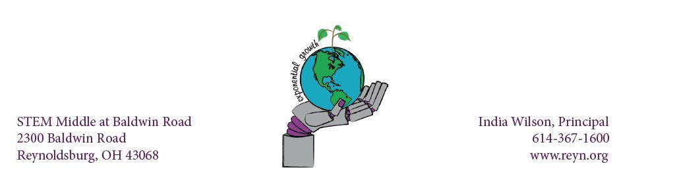

STEM MIDDLE @ BALDWIN ROAD PARENT QUICK GUIDE

TO HYBRID LEARNING

Students with the last name beginning with A-K will report to school on Monday and Tuesday. Students with last name beginning with L-Z will report to school on Thursday and Friday. Students will not report on Wednesdays, and will follow their asynchronous schedules. If your student reports to school on the incorrect day, you will need to provide transportation for your student to return home. They will not be permitted to remain in school on that day.

● Classroom Setup
o Classrooms will be set up with 3 feet of distance between students
o A camera will be placed in a location that can pick up most of the room so that lessons can be live streamed for the Virtual Academy and remote learning students.
● Masks-Students and staff are required to wear masks at all times while in class. If a student does not have their own mask, there are extras that teachers can give to them. Masks must fully cover both the nose and mouth, at all times.
● Student Arrival
o Prior to the doors opening, social distancing and safe behavior (no horseplay or running around) will be enforced.
o When the doors to the building open at 9:00 AM, SMBR students will report to their 1st Period Class. Students will enter the building in an orderly manner.
o Students that want to get breakfast will be allowed to go to the cafeteria, but they will not be permitted to leave the cafeteria with any food. Social distancing will be enforced in line and with seating.
o When the first bell rings at 9:20, students should be in their 1st Period Class. Students are not permitted to congregate in the hallway.
o Students will not be permitted to wait in the vestibule if they are dropped off before 9:00 AM, students will need to stay outside of the building until doors open at 9:00am---please dress appropriately for the weather!
o Students who arrive by bus will enter through the Main Entrance.
o Students who are dropped off by a car will enter through Door 11 on the Right Side of the school.
o Students who walk to school will enter through Door 12 on the Right Side of the school. Please see the video below for more information.
● Classroom Expectations
o Students will clean and sanitize their work area and hands when they arrive to
LDSBURG CITY SCHOOLS
class.
o
dismissed from class.
REYNO Students will clean and sanitize their work area and hands before being

o Students will not be allowed to bring food into class.
o Students will be allowed to bring a water bottle into class.
o Water bottles can be filled at the water station in the cafeteria; drinking fountains will not be available.
o Students without a water bottle will be able to get a cup from the cafeteria to get water.
o All students will have an assigned seat and be required to stay in those seats. Seating charts may be used for contact tracing in the event of an infection.
o Small group activities and labs are still allowed but must include 3 feet of distance and limited/no sharing of supplies.
o During class, there will be scheduled times for students to take movement breaks. If weather permits, students may be taken outside for their break. This is a perfect time for a mask break, with social distancing in place.

● Student Dismissal
o Students will clean and stack chairs on top of desks before being dismissed at the end of the day.
o Bus riders will be dismissed at 3:45 PM and exit through the main doors, all other students will remain in the classroom until 3:50 PM.
o All students will be dismissed at 3:50 PM and exit through either Door 11 if they are being picked up, or Door 12 if they walk home.
o Athletes staying in the building will have until 3:55pm to report to the Cafeteria. Athletes arriving to the building will be briefed on expectations of
arrival time and where to go by their coach. Social distancing will be followed in the cafeteria. Athletes will remain seated, in the designated seats.
● Restrooms
o Only one student will be out of a classroom at a time. Students will sign in and out. No passes will be given the first and last ten minutes of class.
o No more than three students will be allowed in a restroom at a time.
▪ We will be patient with students taking a restroom break due to these restrictions.
● Hallways
o During class changes, students will need to adhere to the ONE-WAY directives that have been put in place. Arrows are visible on the walls for assistance. Teacher will practice with students on these expectations.
● Breakfast/Lunch
o Students will wash and sanitize their hands and their eating area when entering the cafeteria.
o Students will wash and sanitize their hands and their eating area before exiting the cafeteria.
o No food can leave the cafeteria--this means no eating breakfast or lunch in classrooms.
● Chromebooks
o All students have a Chromebook assigned to them and should be bringing that to class with them every day and taking it home to charge every night.
REYNOLDSBURG CITY SCHOOLS

o If a student leaves their Chromebook at home, they will not be able to borrow one from school because all Chromebooks are assigned to students at this point.
o Students that don’t have their Chromebook with them on a day that requires technology will be given an alternative assignment to work on.
● Wednesday Schedule Change
o All students will be working from home on Wednesdays.
o Students will have assignments for all classes and these assignments should be about 30-45 minutes in length for each class.
o Teachers will hold virtual office hours on Wednesdays where students can drop in and get extra help with classes or retake assessments.
o Wednesday schedule will be as follows: ▪ 8:30-9:10am – Advisory
▪ 9:15am-1:30pm – Purposeful Grouping, Student Rotations, Intervention, Enrichment, PBIS, SEL, ELL, etc.
▪ Individual Grade Level Teams will reach out to families regarding the specific schedule for these days.

Please click on the following link to watch a video that goes over important safety information when we return to the building in our Hybrid Model. Hybrid Safety at SMBR

5th Grade Hybrid Bell Schedule
Period 1 | 9:20am – 10:26am
Recess | 10:28am – 10:43am
Lunch | 10:46am – 11:16am
Period 2 | 11:20am – 12:28pm
Advisory | 12:32pm – 1:07pm
Period 3 | 1:11pm – 2:19pm
Recess Again | 2:23pm - 2:38pm
Period 4 | 2:42pm – 3:50pm
6th Grade Hybrid Bell Schedule
Period 1 | 9:20am – 10:35am
Advisory | 10:39am – 11:14am
Lunch | 11:18am – 11:48pm
Period 2 | 11:52pm - 1:07pm
Period 3 | 1:11pm – 2:26pm
Period 4 | 2:30pm – 3:50pm

7th Grade Hybrid Bell Schedule 8th Grade Hybrid Bell Schedule

REYNOLDSBURG CITY SCHOOLS
Period 1 | 9:20am – 10:35am
Period 2 | 10:39am – 11:54pm
Lunch | 11:58am – 12:28pm
Advisory | 12:32pm – 1:07pm
Period 3 | 1:11pm – 2:26pm
Period 4 | 2:30pm – 3:50pm
Period 1 | 9:20am – 10:35am
Period 2 | 10:39am – 11:54am
Advisory | 11:58am – 12:33pm
Lunch | 12:37pm – 1:07pm
Period 3 | 1:11pm – 2:26pm
Period 4 | 2:30pm – 3:50pm

