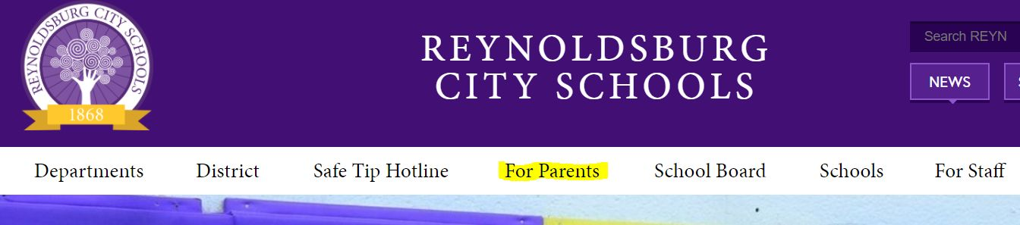
Families,
In an effort to ensure equity of report cards and the timeliness of distribution, your child’s report card will be available online in PowerSchool. If you are not able to login and view your student’s report, please contact the building secretary for further instructions.

You can log into PowerSchool on the Reynoldsburg home page under For Parents.

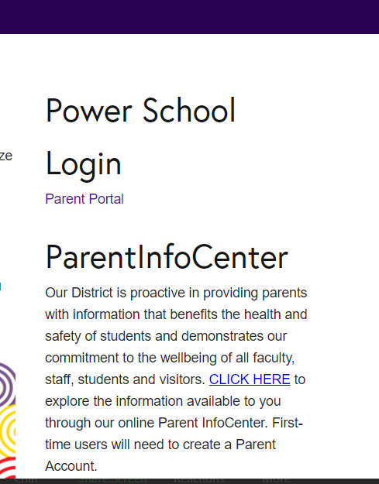
On the right side of the page, click Parent Portal under the PowerSchool Login.

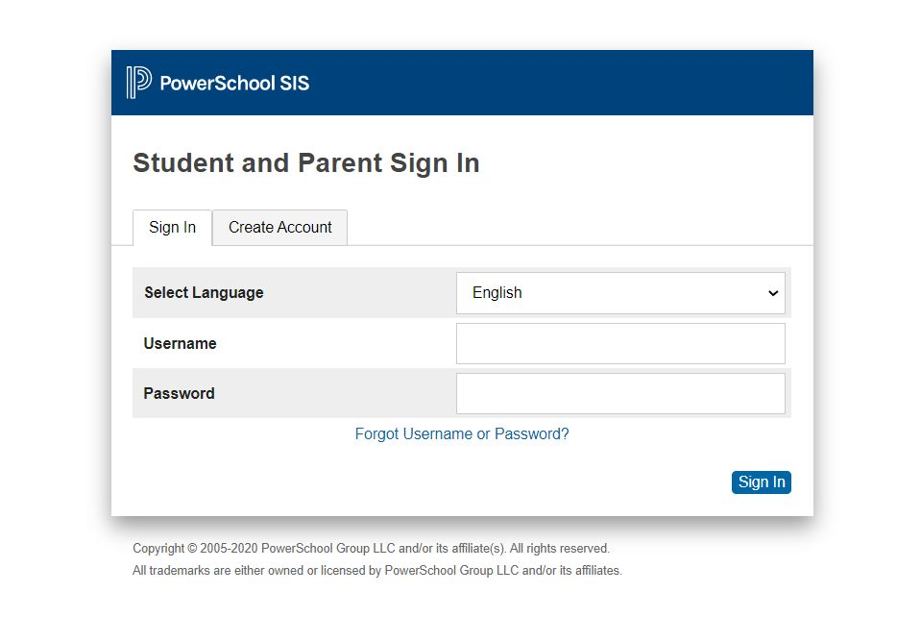
The Parent and Student Login screen will open.

Enter your username and password that was provided to you by your student’s school in the beginning of the year. If you need the information again, please contact your building secretary.

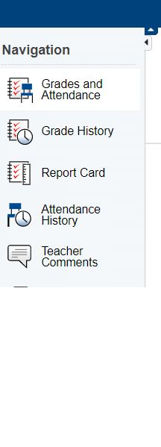
Click Report Card on the left side menu to view your student’s report.

If you would like to print the report card, click the printer icon in the upper right corner print as you normally would.

